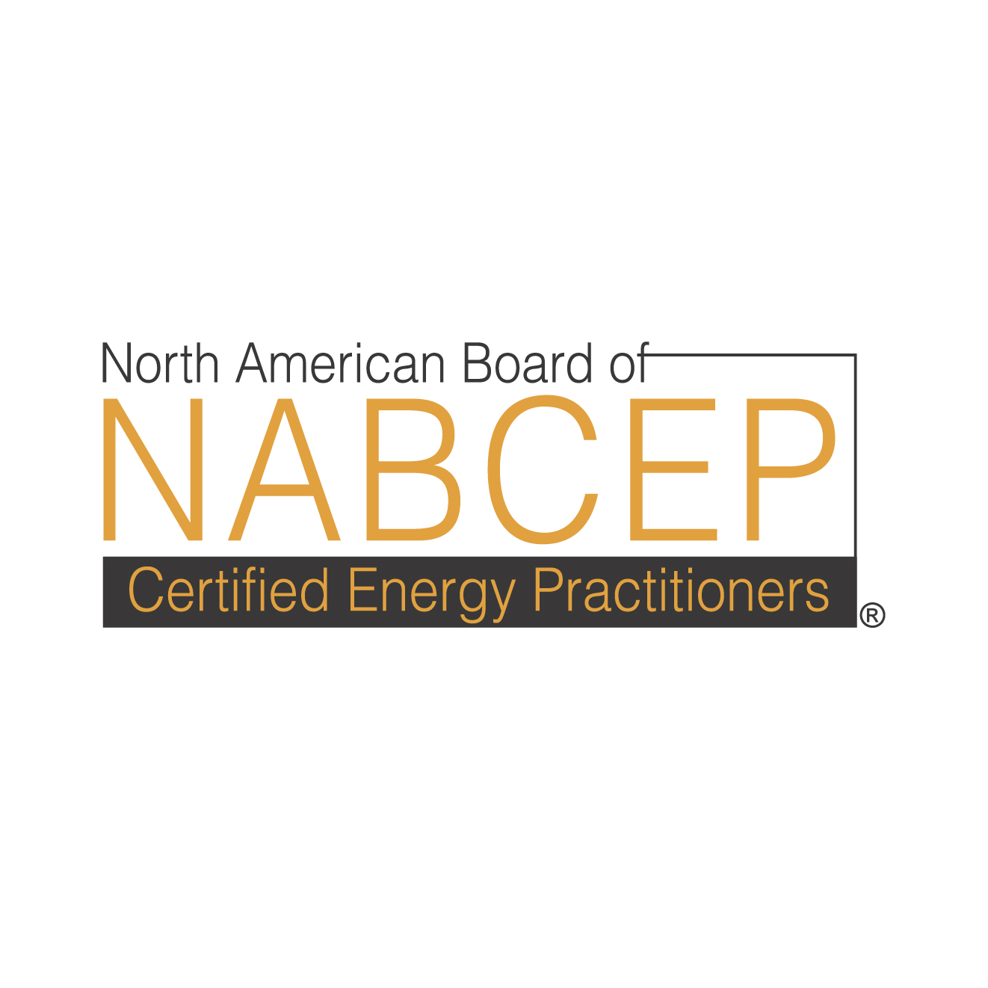

AGREEMENT FORM
FOR PROVIDERS

NABCEP PV ENTRY LEVEL CERTIFICATE OF KNOWLEDGE

In consideration of NABCEP’s decision to designate the undersigned organization as a Registered Provider of the NABCEP PV Entry Level Certificate of Knowledge, the Provider agrees to keep confidential and secure all NABCEP test information and materials, including, but not limited to: test items; examination forms; and all other test or examination-related materials. The Provider further agrees to use the same care and discretion to avoid disclosure, publication, or dissemination of NABCEP information and materials as the Provider uses with its own similar information that it does not wish to disclose, publish or disseminate. The Provider will report to NABCEP any potential or real breaches of security caused by, or known to, the Provider, or any of its representatives or agents as soon as such breaches are known or should have been known.

Provider Signature________________________________________________________

Print Name______________________________________________________________

Date______________________________________

Please return the form to:
Karen Christopher, Operations Manager
North American Board of Certified Energy Practitioners
Saratoga Technology + Energy Park
10 Hermes Road Malta, NY 12020
Phone: (518) 899-8186 Fax: (518) 899-1092
Email : kchristopher@nabcep.org

